
PATUAKHALI SCIENCE AND TECHNOLOGY UNIVERSITY
COURSE CODE CIT-112

SUBMITTED TO:

Md. Mahbubur Rahman

Department of Computer Science and Information Technology
Faculty of Computer Science and Engineering

SUBMITTED BY:
Md. Sharafat Karim
ID: 2102024,
Registration No: 10151
Faculty of Computer Science and Engineering

Date of submission: 13 April, 2023
Assignment: 05
Assignment title: Basic C, chapter 5

Index
- word slicing
- floating point expression evaluation
- round of to integer
- horizontal bar
- process of multiplication
- conversion specifier
- exponential format
- floating point format
- formatted name
- table of data
- sample data
- pascals triangle
- Dollar to INR and Euro
- triangle pattern
- cumulative deposit

// word slicing
#include <stdio.h>
#include <string.h>

int main()
{
printf("sharafat 2102024\n\n");
char s[16];
scanf("%s", s);

int i;
for (i = 0; i < strlen(s); i++)
{
if (i == 4)
printf(" ");
putchar(s[i]);
}
printf("\n");

for (i = 0; i < strlen(s); i++)
{
if (i == 4)
printf("\n");
putchar(s[i]);
}
printf("\n");

for (i = 0; i < strlen(s); i++)
{
if (i == 0 || i == 4)
printf("%c.", s[i]);
}
}

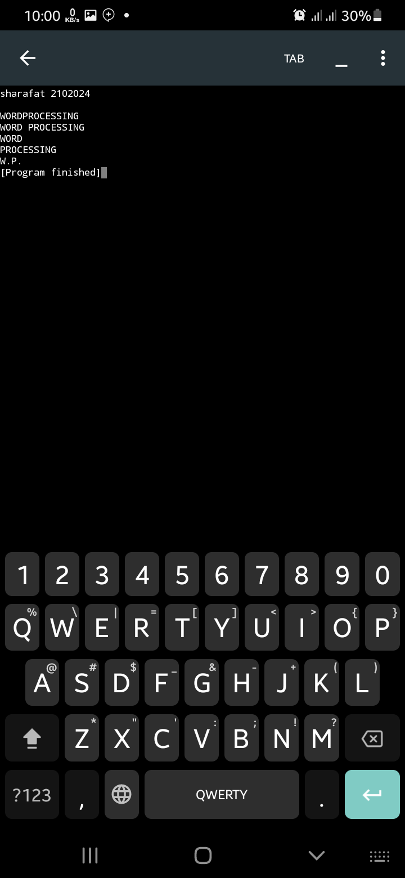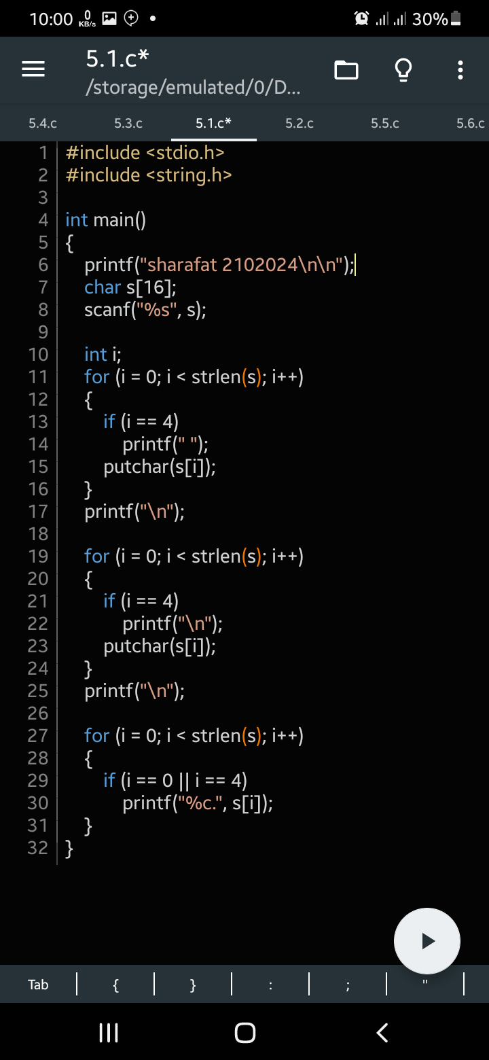

// floating point expression evaluation
#include<stdio.h>
#include<math.h>

int main()
{
printf("sharafat 2102024\n\n");
float x, y;
scanf("%f %f", &x, &y);
printf("%f %f %f \n", ((x+y)/(x-y)), (x+y)/2, (x+y)*(x-y));
}

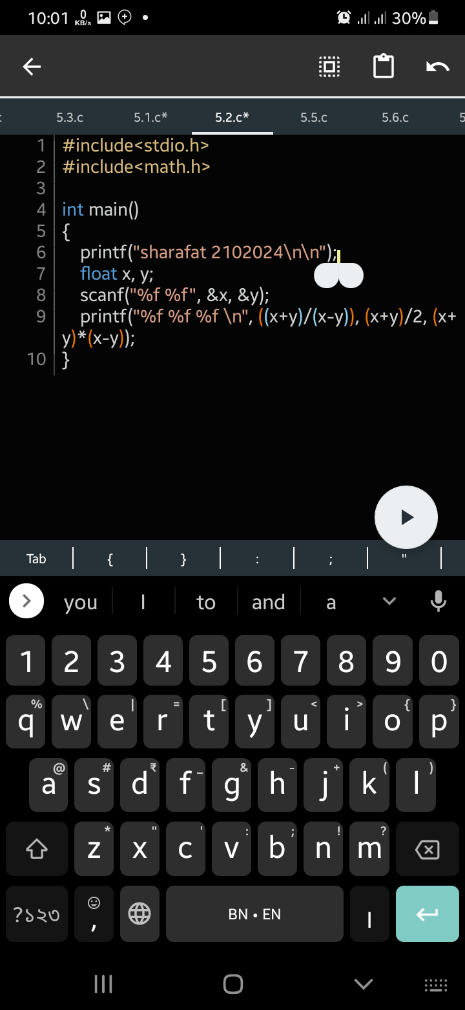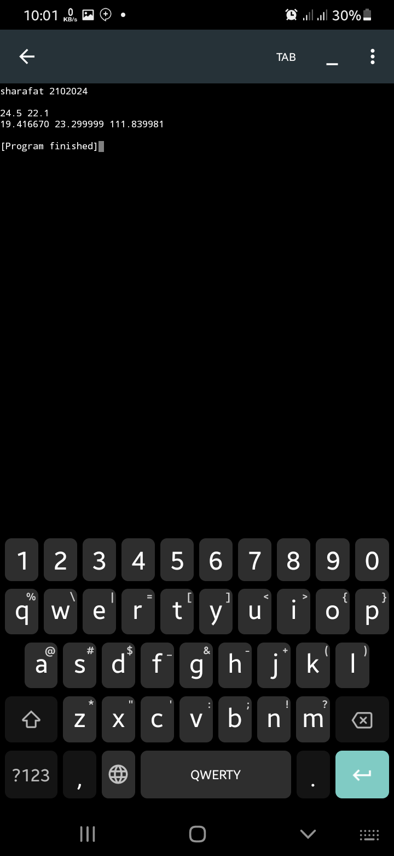

// 3 round off to integer
#include<stdio.h>
#include<math.h>

int main()
{
printf("sharafat 2102024\n\n");

float n;
scanf("%f", &n);
printf("%d\n", (int) round(n));
}

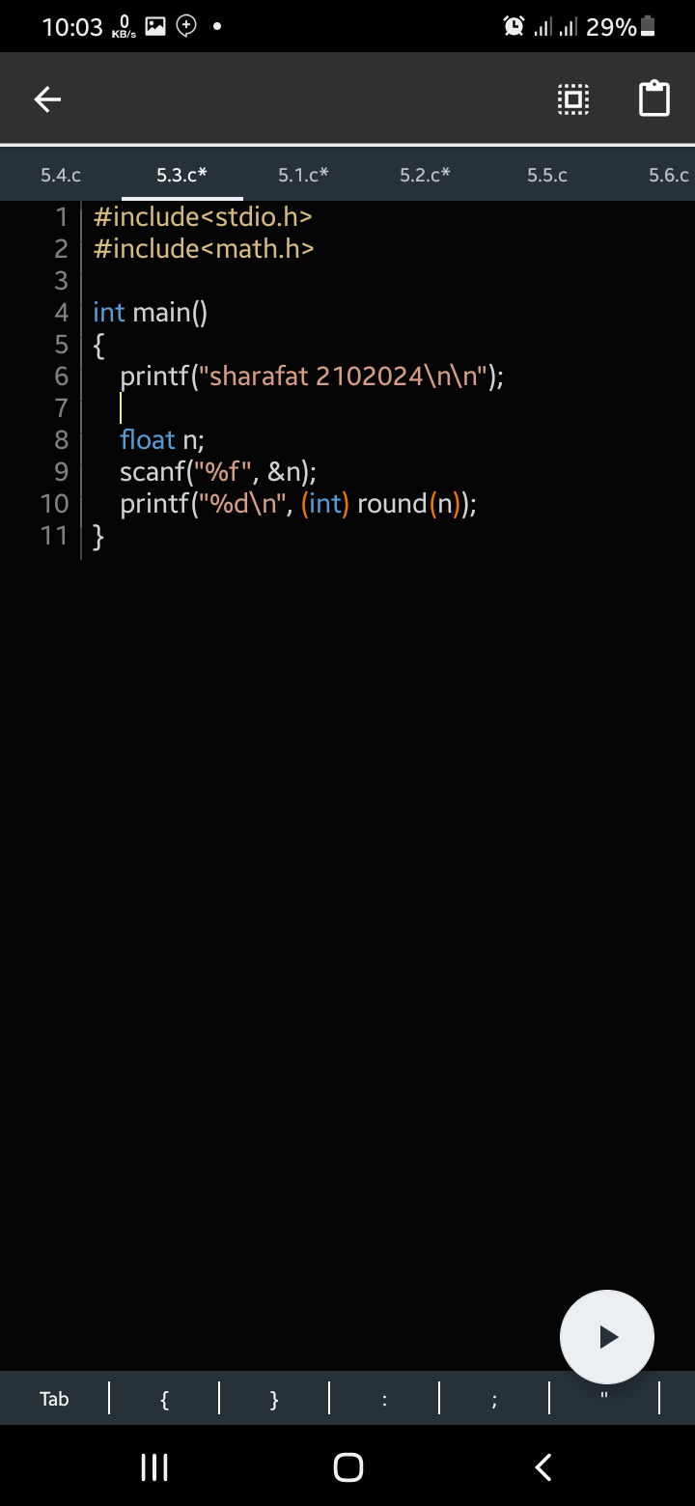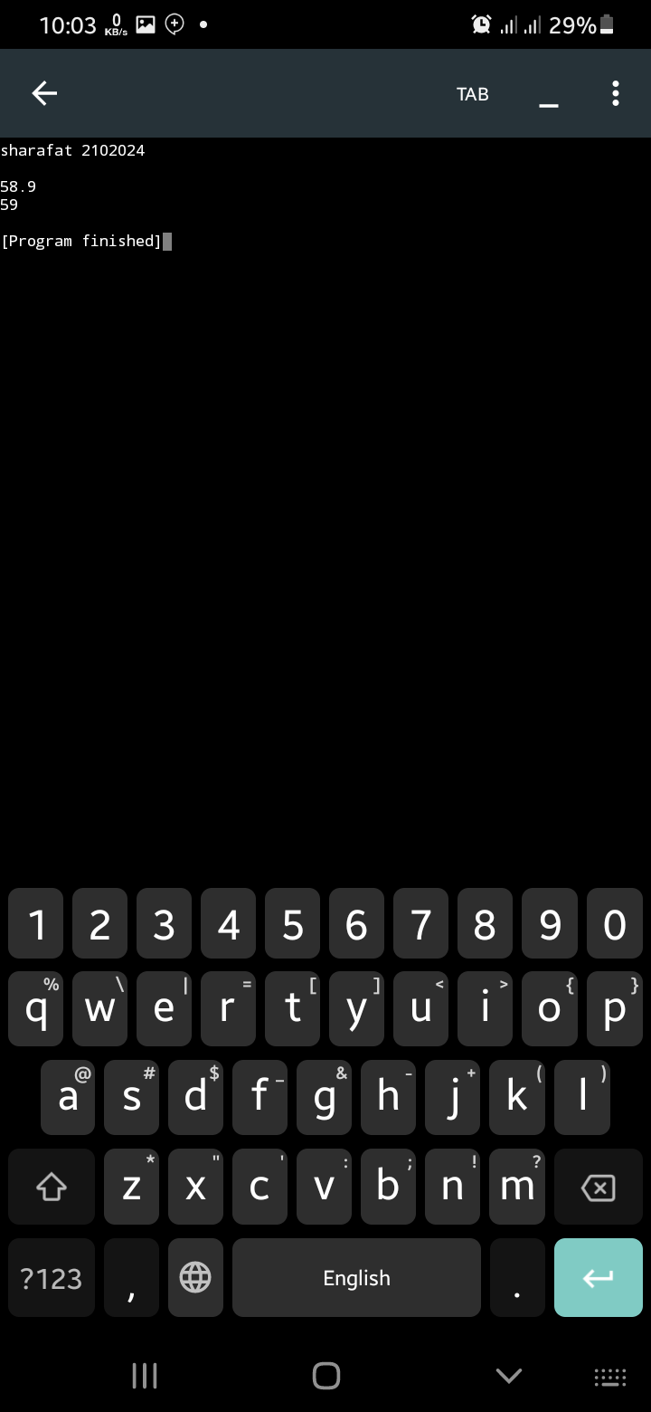

// horizontal bar
#include<stdio.h>
#include<math.h>
int main()
{
printf("sharafat 2102024\n\n");
float n;
int i;
scanf("%f", &n);

for (i=0; i < round(n); i++)
printf("* ");
printf("\n");

for (i=0; i < round(n); i++)
printf("* ");
printf(" %2f\n", n);

for (i=0; i < round(n); i++)
printf("* ");
printf("\n");
}

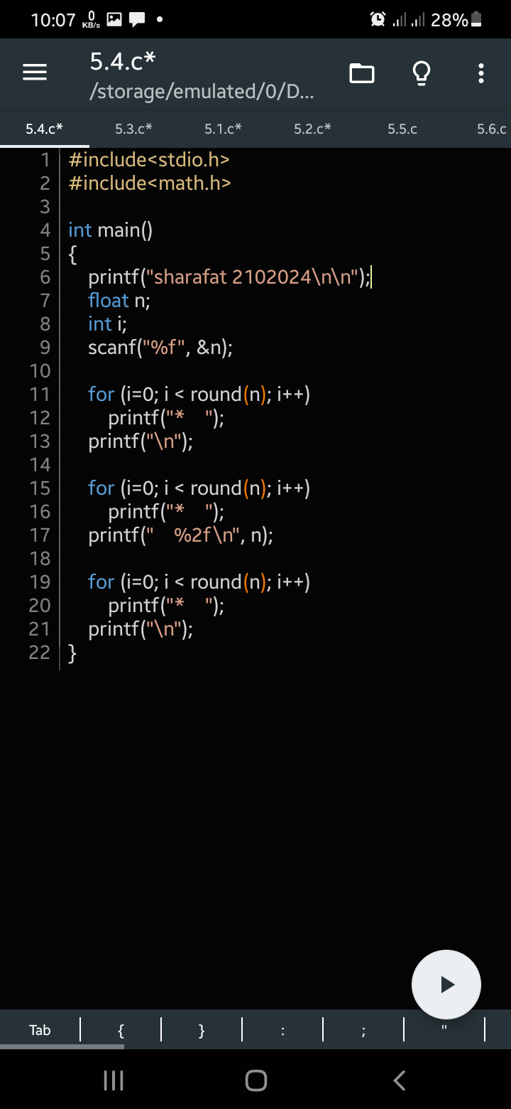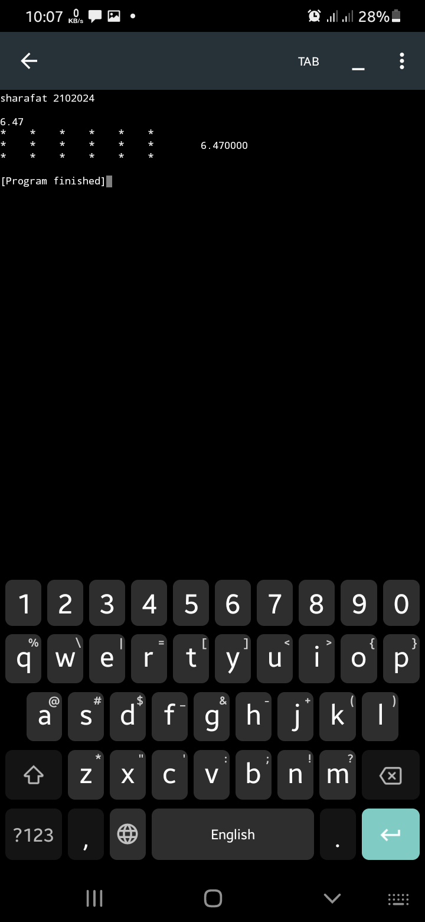

// process of multiplication
#include <stdio.h>
#include <math.h>

int main()
{
printf("sharafat 2102024\n\n");

int x, y;
printf("Enter first number: ");
scanf("%d", &x);
printf("Enter second number: ");
scanf("%d", &y);
printf("%24d \n", x);
printf(" x%8d \n", y);
printf(" ---------\n");
printf(" %d x %d is %6d\n", y % 10, x, (y % 10) * x);
printf(" %d x %d is %6d\n", y / 10, x, (y / 10) * x);
printf(" ---------\n");
printf("Add them %8d\n", x * y);
printf(" ---------\n");
}
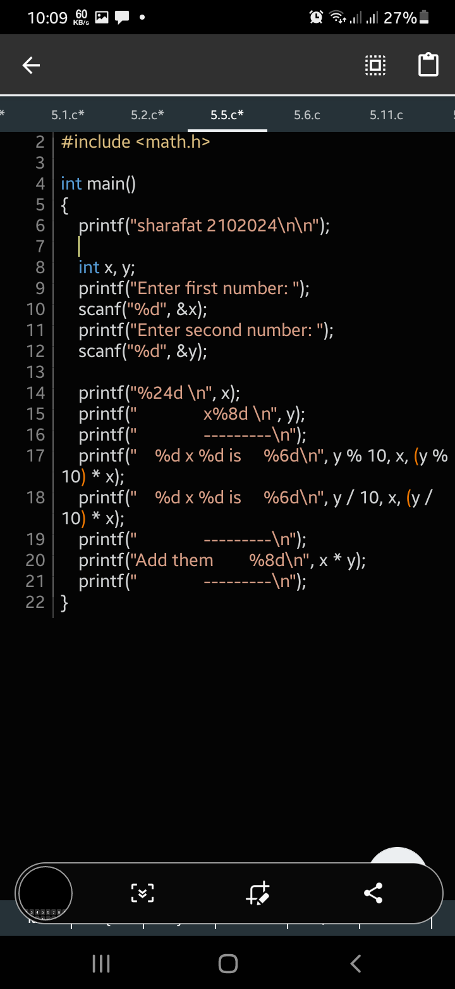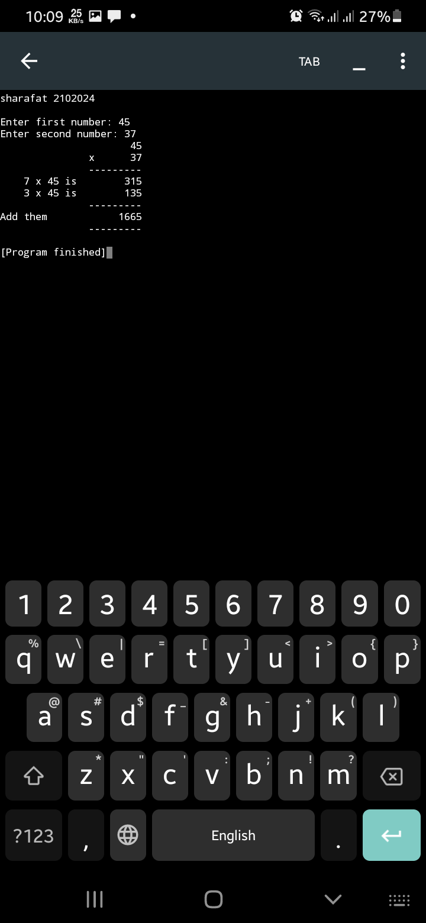

// 6 conversion specifier
#include <stdio.h>
#include <math.h>

int main()
{
printf("sharafat 2102024\n\n");

float x, y, z;
scanf("%f %f %f", &x, &y, &z);
printf("%f", x);
printf("%f", y);
printf("%f\n", z);

printf("%4.2f %4.2f %4.2f \n", x, y, z);
printf("%f %f %f \n", x, y, z);
}

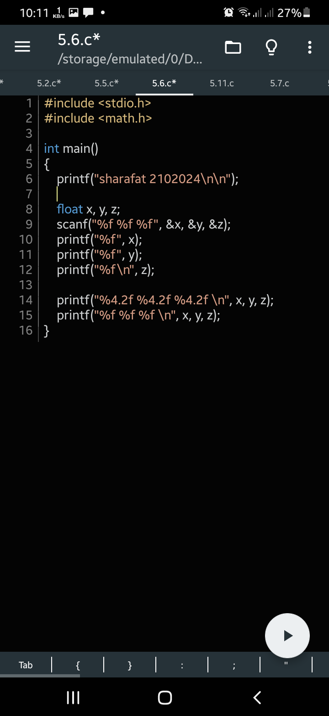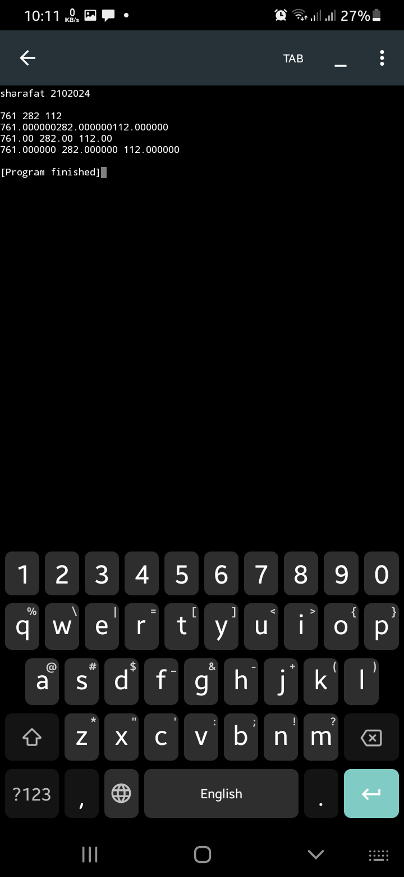

// exponential format
#include <stdio.h>

int main()
{
printf("sharafat 2102024\n\n");

double value = 10.45678;

printf("Correct to two decimal places: %.2e\n", value);
printf("Correct to four decimal places: %.4e\n", value);
printf("Correct to eight decimal places: %.8e\n", value);

return 0;
}

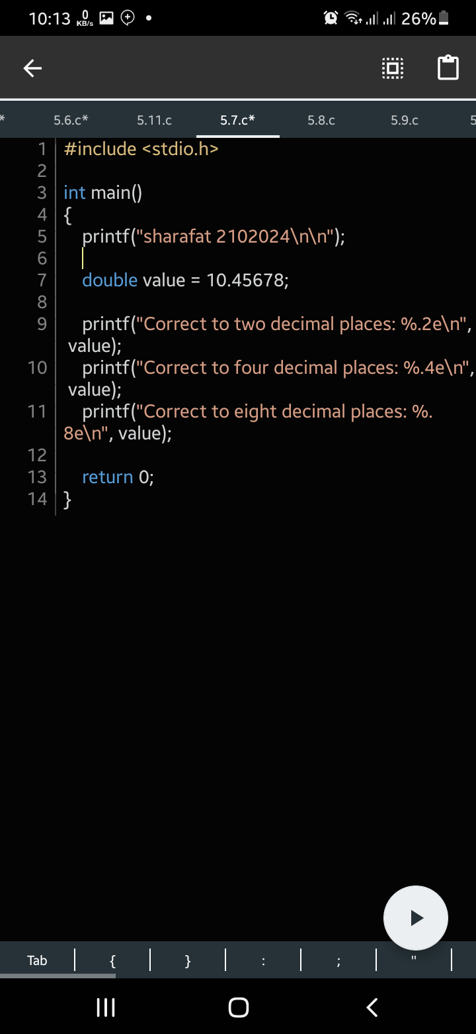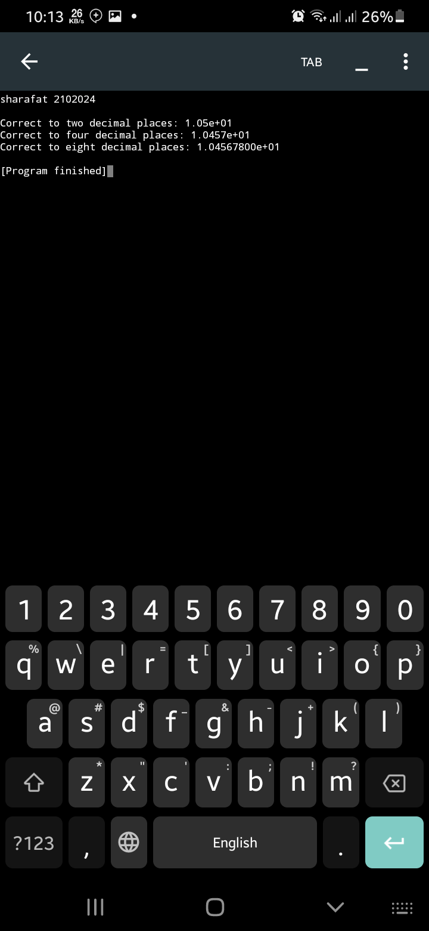

// floating point format
#include <stdio.h>

int main()
{
printf("sharafat 2102024\n\n");

double value = 10.45678;

printf("Correct to two decimal places: %.2f\n", value);
printf("Correct to four decimal places: %.4f\n", value);
printf("Correct to eight decimal places: %.8f\n", value);

return 0;
}

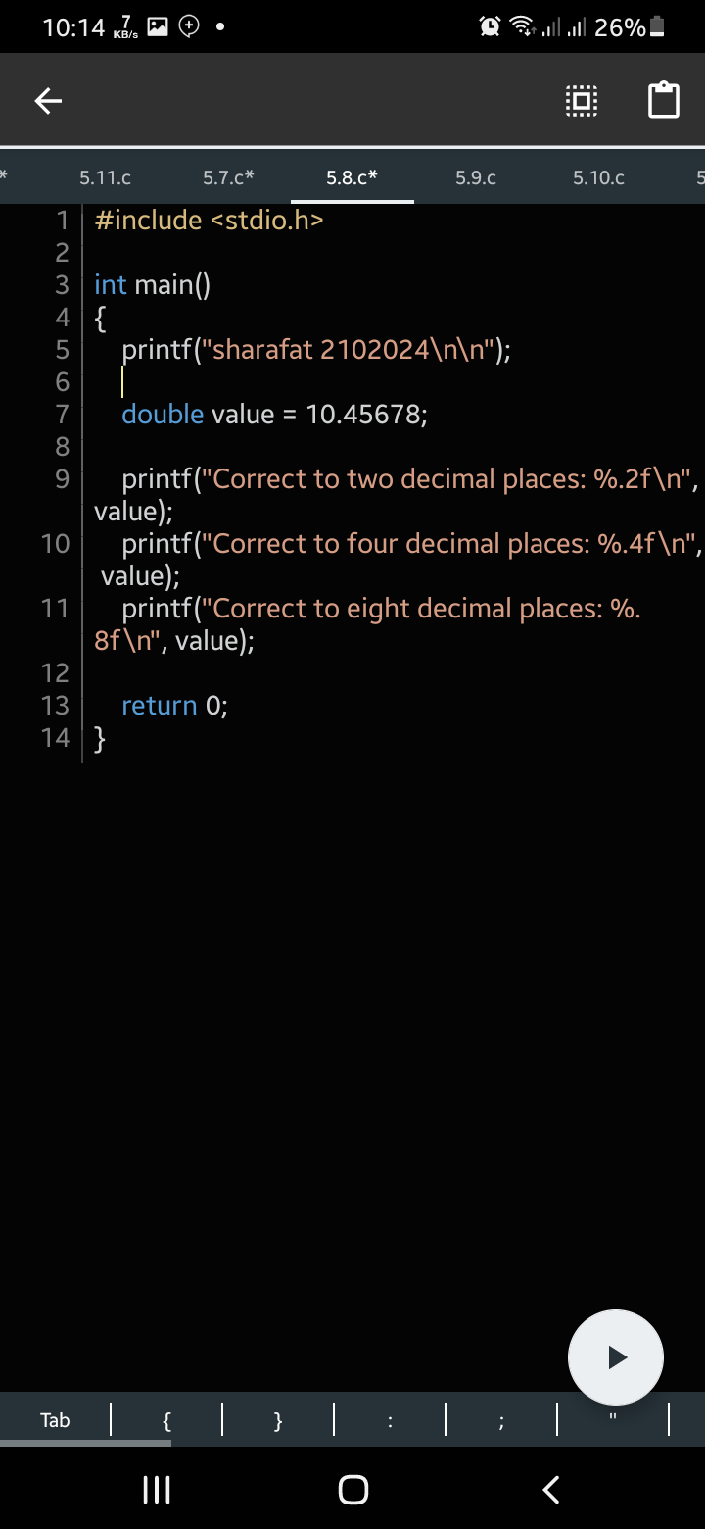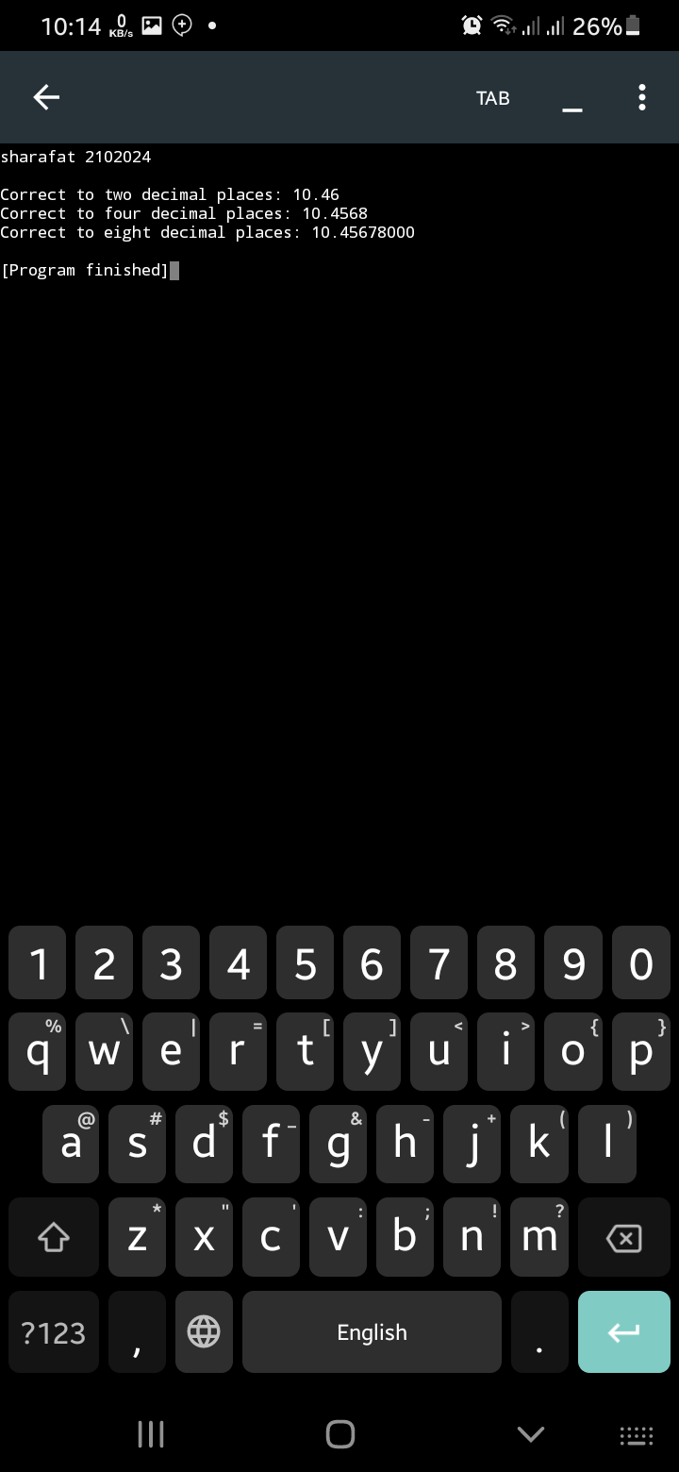

// formatted name
#include <stdio.h>
#include <string.h>

int main() {
printf("sharafat 2102024\n\n");
char first[10], middle[3], last[10];

printf("Enter the name in three parts: ");
scanf("%s %s %s", first, middle, last);

printf("Formatted Name A: %s %s. %s\n", first, middle, last);
printf("Formatted Name B: %c.%c. %s\n", first[0], middle[0], last);
printf("Formatted Name C: %s %c.%c.\n", last, first[0], middle[0]);

return 0;
}

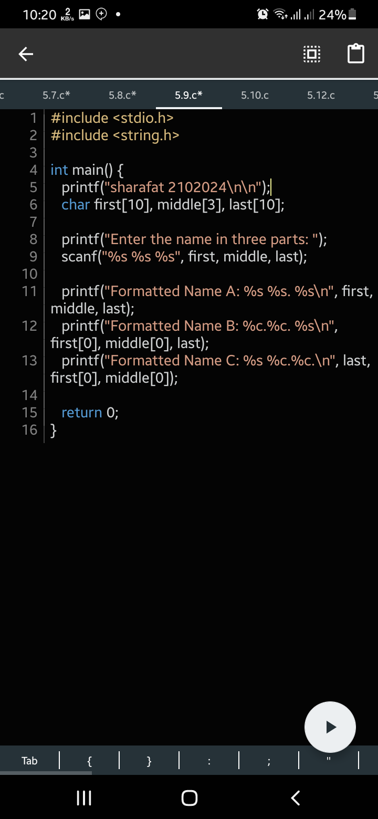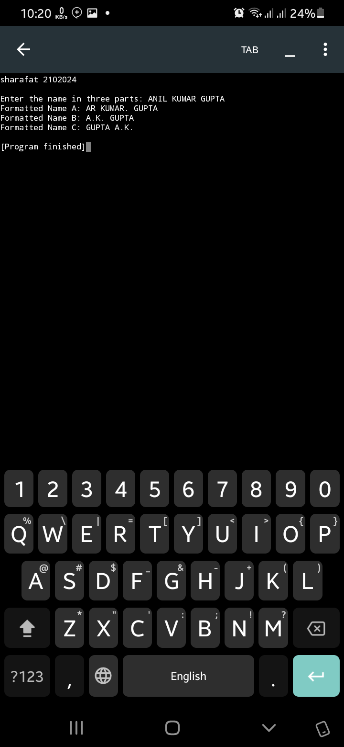

// table of data
#include <stdio.h>

int main()
{
printf("sharafat 2102024\n\n");

char name1[10], name2[10];
int code1, code2;
float price1, price2;

printf("Enter name, code and price for first person\n");
scanf("%s %d %f", name1, &code1, &price1);
scanf("%s %d %f", name2, &code2, &price2);

printf("%-10s %-8s %10s\n", "NAME", "CODE", "PRICE");
printf("%-10s %-8d %10.2f\n", name1, code1, price1);
printf("%-10s %-8d %10.2f\n", name2, code2, price2);

return 0;
}

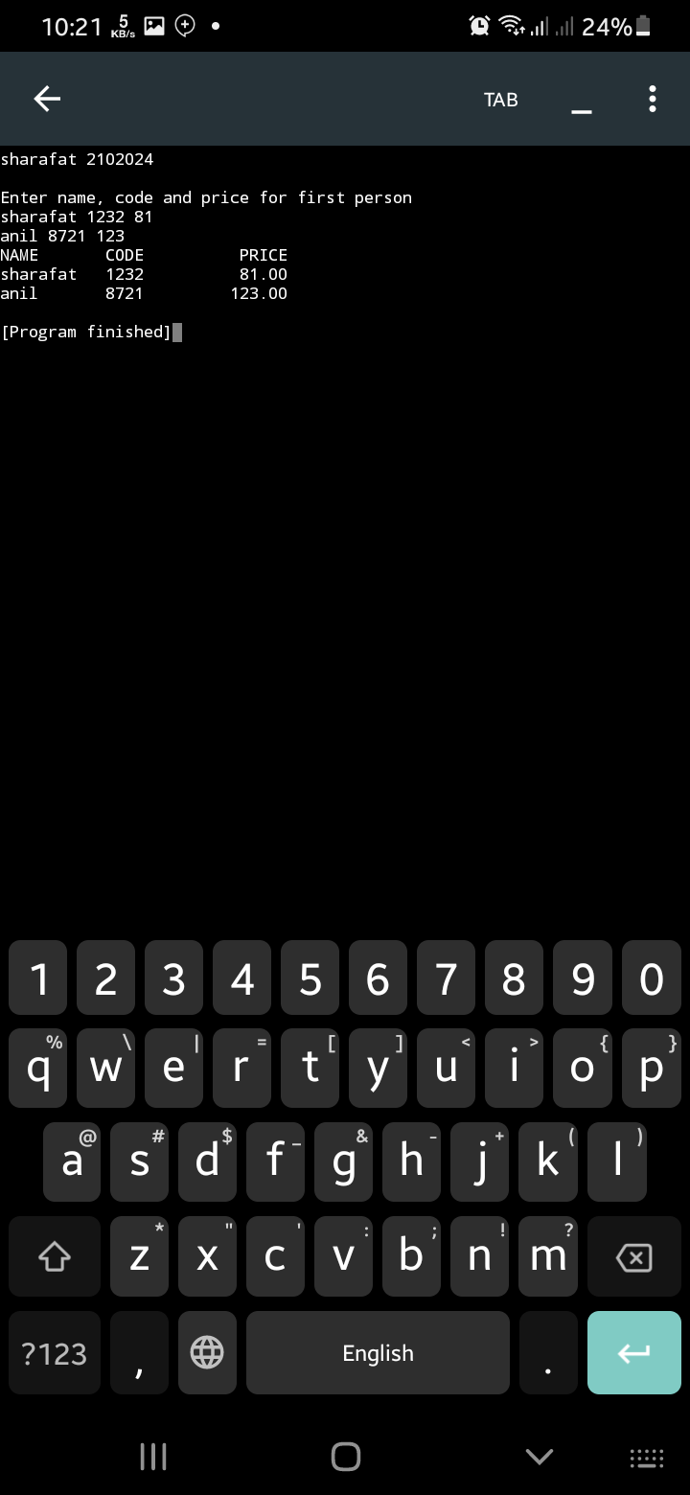

// sample data
#include <stdio.h>
int main()
{
printf("sharafat 2102024\n\n");
printf("Inventory Stock Report\n");
printf("----------------------\n");
printf("Item Code | Quantity | Location\n");
printf("--------------------------------\n");
printf("%9d | %8d | %8s\n", 37837, 2, "Dhaka" );
printf("%9d | %8d | %8s\n", 14567, 1, "Khulna" );
printf("%9d | %8d | %8s\n", 975737, 8, "Chandpur" );
return 0;
}

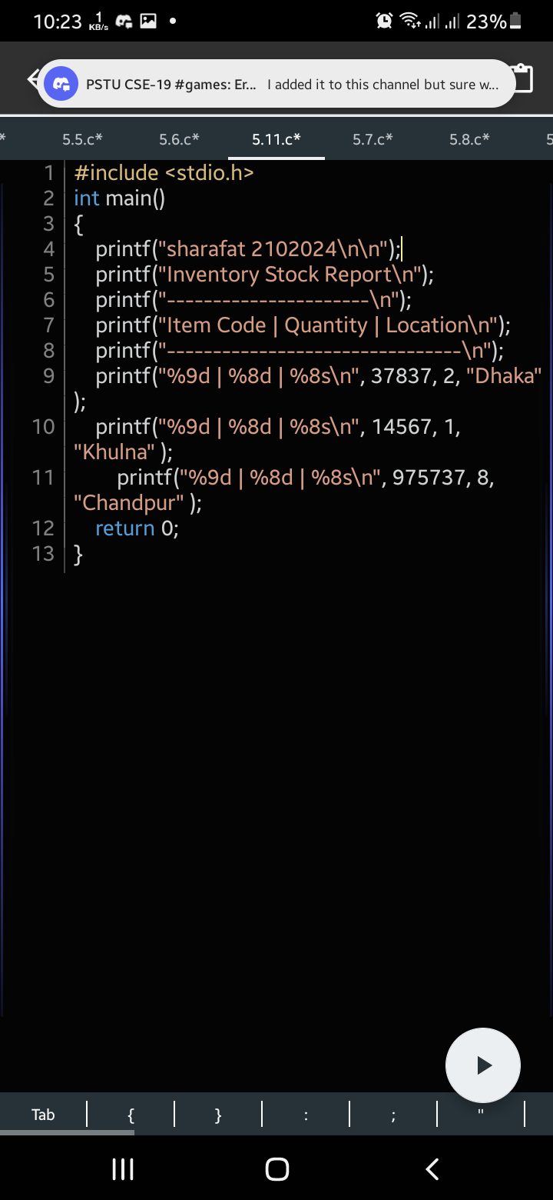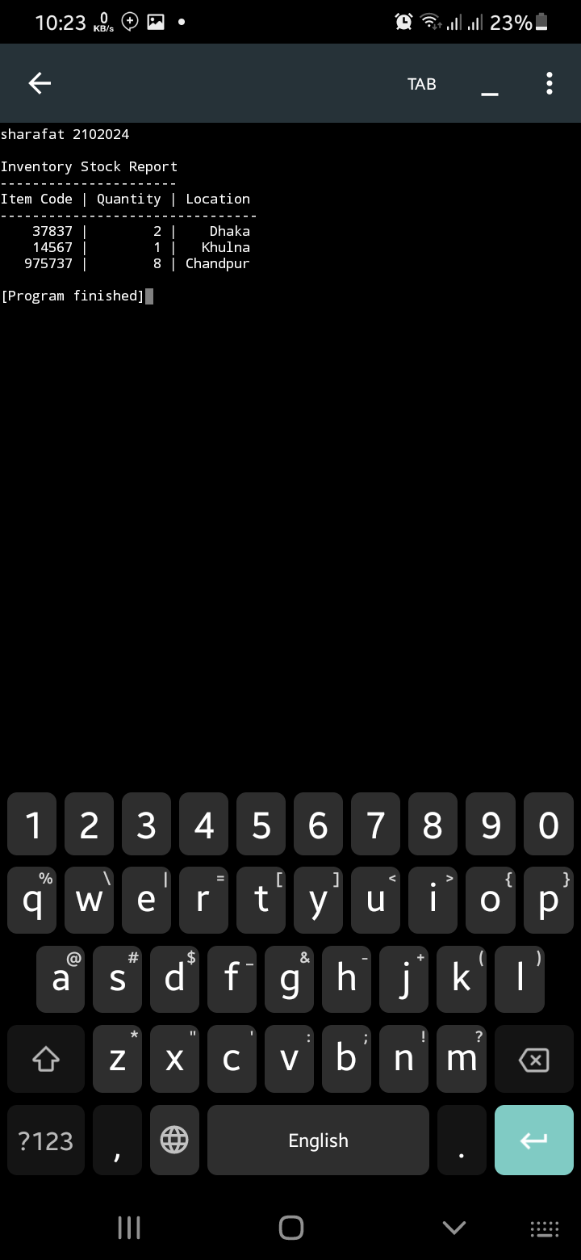

// Pascal's triangle
#include <stdio.h>

int main()
{
printf("sharafat 2102024\n\n");

int rows, i, j, coef = 1;

printf("Enter the number of rows: ");
scanf("%d", &rows);

for (i = 0; i < rows; i++)
{
for (j = 0; j <= i; j++)
{
if (j == 0 || i == 0)
coef = 1;
else
coef = coef * (i - j + 1) / j;
printf("%d ", coef);
}
printf("\n");
}

return 0;
}

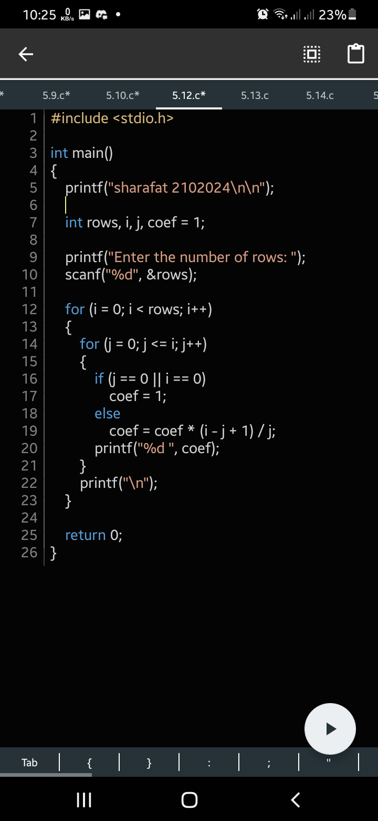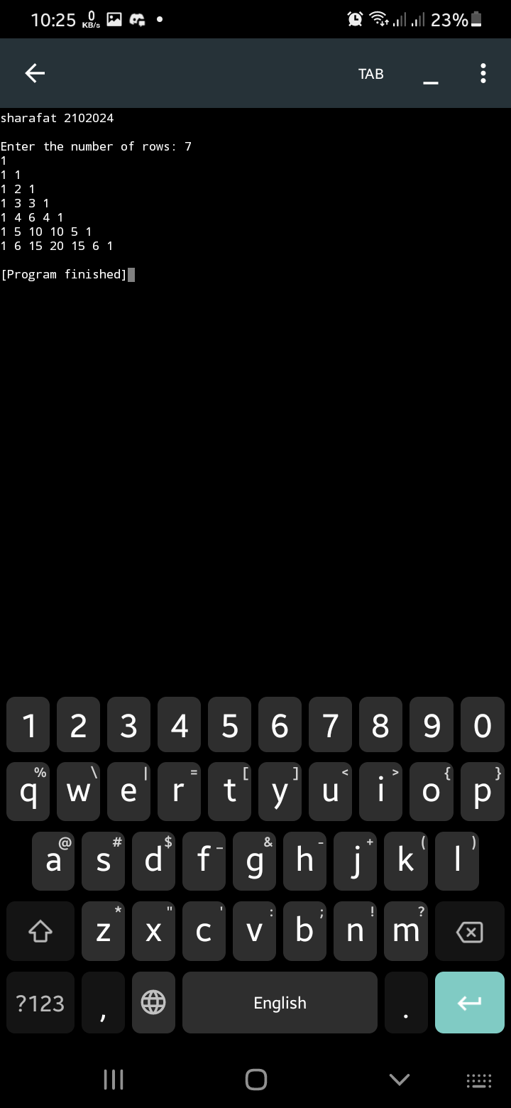

// 13 Dollar to INR and Euro
#include <stdio.h>

int main()
{
printf("sharafat 2102024\n\n");

float dollarAmount, exchangeRateEuro = 0.91, exchangeRateINR = 81.96;
float euroAmount, INRAmount;

printf("Enter dollar amount: ");
scanf("%f", &dollarAmount);

euroAmount = dollarAmount * exchangeRateEuro;
INRAmount = dollarAmount * exchangeRateINR;

printf("%.2f dollars is equivalent to %.2f euros and %.2f INR\n", dollarAmount, euroAmount, INRAmount);

return 0;
}

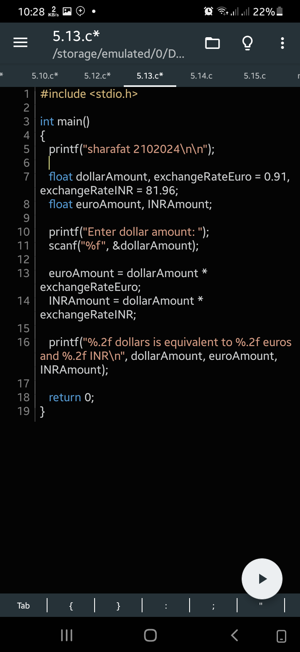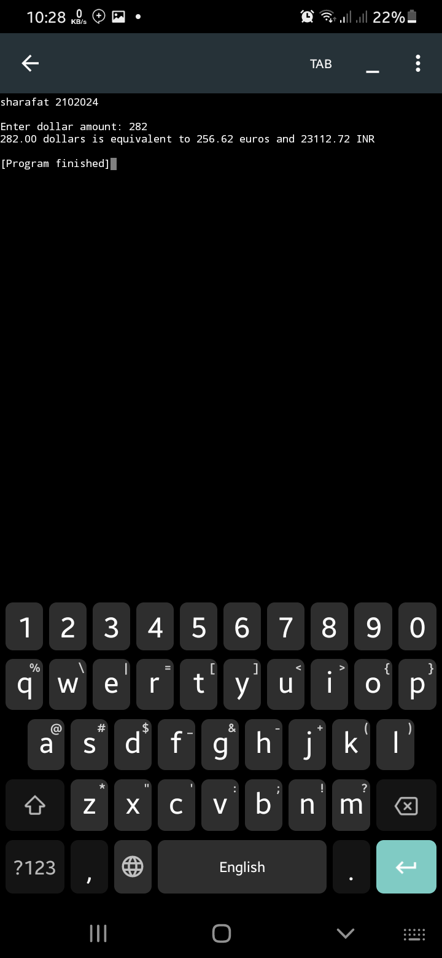

// 14 triangle pattern
#include <stdio.h>

int main()
{
printf("sharafat 2102024\n\n");
int rows, i, j, coef = 1;

printf("Enter the number of rows: ");
scanf("%d", &rows);

for (i = 0; i < rows; i++)
{
for (j=0; j<=i; j++)
printf(" ");
for (j = rows-i; j >=1; j--)
{
printf("%d ", j);
}
printf("\n");
}

return 0;
}

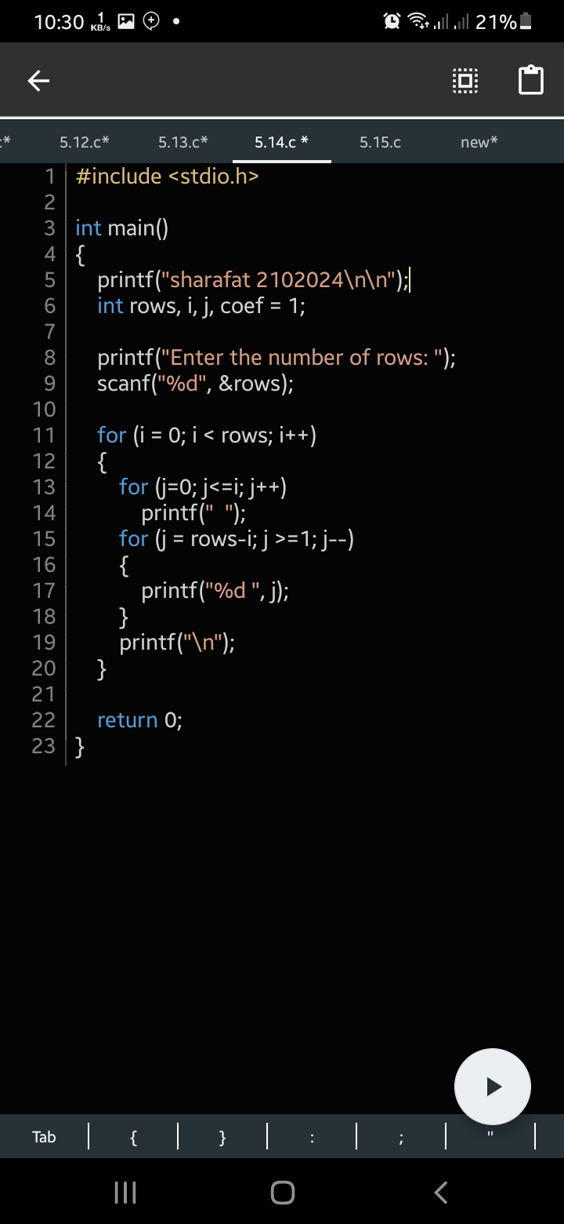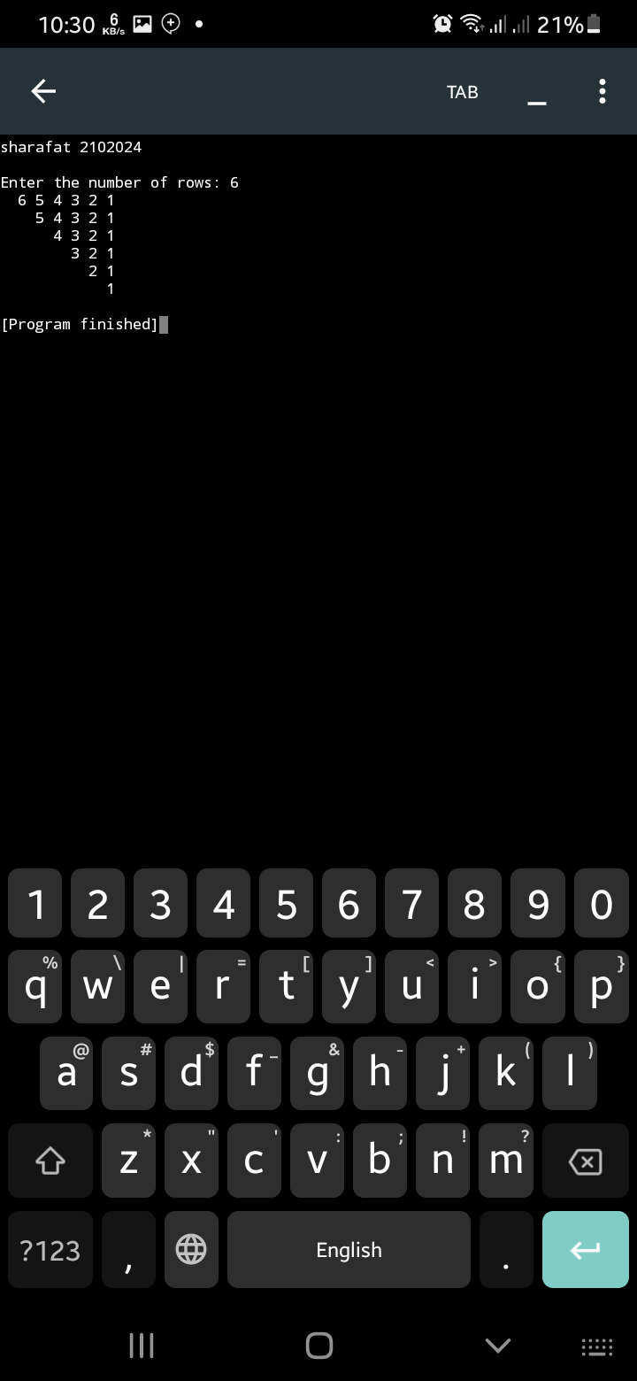

// 15 cumulative deposit
#include <stdio.h>
#include <math.h>

int main()
{
printf("sharafat 2102024\n\n");
double investment, rate_of_interest, final_amount;
int years = 10;

printf("Enter the investment amount: ");
scanf("%lf", &investment);

rate_of_interest = 8.75 / 100.0;

final_amount = investment * pow((1 + rate_of_interest), years);

printf("The final amount after %d years is %.2lf", years, final_amount);

return 0;
}
